ISLAMIC UNIVERSITY OF TECHNOLOGY
DHAKA, BANGLADESH
ORGANIZATION OF ISLAMIC COOPERATION
DATABASE MANAGEMENT SYSTEMS LAB

Name: Antara Arifa Mullick
Student ID: 210042132
Department: Computer Science and Engineering
Program: B.Sc. in Software Engineering

Report preparing for Lab Task

Task 1:
Create a user with username = <C_student_id> and password = cse4308 and grant necessary privileges to log in and execute DDL and DML statements. Then log in as that user.
Solution Approach:
CREATE USER C_210042132 IDENTIFIED BY cse4308 ;
GRANT ALL PRIVILEGES TO C_210042132;
CONNECT C_210042132 / cse4308 ;
SQL Command:
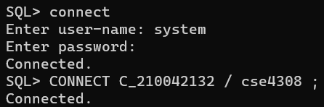
Task 2:
Write SQL statement to create a table ‘INSTRUCTOR’ which has 4 attributes:
• ID (assign it as Primary Key)
• NAME
• DEPT_NAME
• SALARY (ensure that SALARY is greater than 20000)
Solution Approach:
CREATE TABLE INSTRUCTOR
(
ID VARCHAR2(5) ,
NAME VARCHAR2 (20) NOT NULL ,
DEPT_NAME VARCHAR2(20) ,
SALARY NUMBER(5) ,
CONSTRAINT PK_IDENTITY PRIMARY KEY ( ID ),
CONSTRAINT SALARY_CHECK CHECK (SALARY > 20000 )
);
SQL Command:
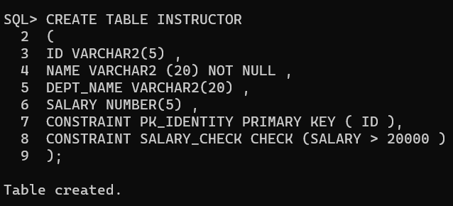
Task 3:
Write SQL statements to insert the following records into ‘INSTRUCTOR’ table:
ID | NAME | DEPT_NAME | SALARY
10101 | Srinivasan | Comp. Sci. | 65000
12121 | Wu | Finance | 90000
15151 | Mozart | Music | 40000
22222 | Einstein | Physics | 95000
32343 | El Said | History | 60000
00456 | Gold | Physics | 87000
45565 | Katz | Comp. Sci. | 75000
58583 | Califieri | History | 62000
76543 | Singh | Finance | 80000
76766 | Crick | Biology | 72000
03821 | Brandt | Comp. Sci. | 92000
98345 | Kim | Elec. Eng. | 80000

Solution Approach:
INSERT INTO INSTRUCTOR VALUES (’10101’ , ’Srinivasan’ , ’Comp.Sci.’ , 65000 );
INSERT INTO INSTRUCTOR VALUES (’12121’ , ’Wu’ , ’Finance’ , 90000 );
INSERT INTO INSTRUCTOR VALUES (’15151’ , ’Mozart’ , ’Music’ , 40000 );
INSERT INTO INSTRUCTOR VALUES (’22222’ , ’Einstein’ , ’Physics’ , 95000 );
INSERT INTO INSTRUCTOR VALUES (’32343’ , ’El Said’ , ’History’ , 60000 );
INSERT INTO INSTRUCTOR VALUES (’00456’ , ’Gold’ , ’Physics’ , 87000 );
INSERT INTO INSTRUCTOR VALUES (’45565’ , ’Katz’ , ’Comp. Sci.’ , 75000 );
INSERT INTO INSTRUCTOR VALUES (’58583’ , ’Califieri’ , ’History’ , 62000 );
INSERT INTO INSTRUCTOR VALUES (’76543’ , ’Singh’ , ’Finance’ , 80000 );
INSERT INTO INSTRUCTOR VALUES (’76766’ , ’Crick’ , ’Biology’ , 72000 );
INSERT INTO INSTRUCTOR VALUES (’03821’ , ’Brandt’ , ’Comp. Sci.’ , 92000 );
INSERT INTO INSTRUCTOR VALUES (’98345’ , ’Kim’ , ’Elec. Eng.’ , 80000 );

SQL Command: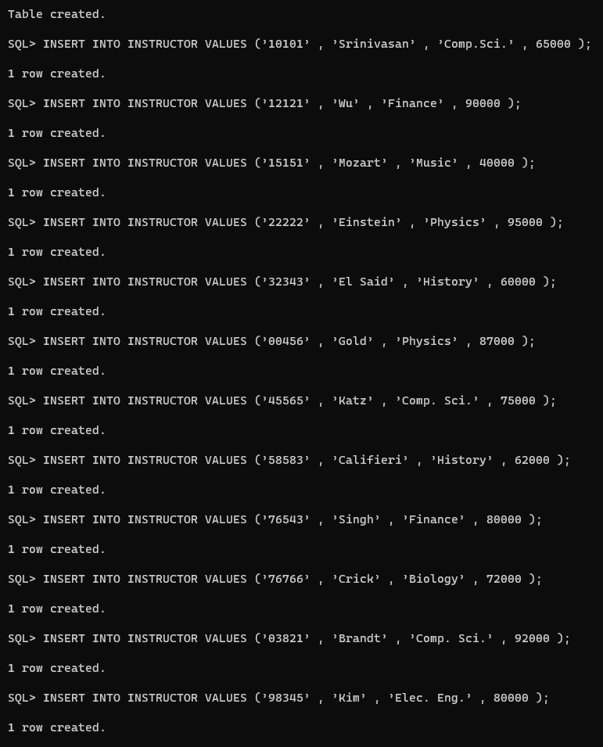

Task 4:
Write SQL statements to perform the following queries:
(a) Display all records of ‘INSTRUCTOR’ table.
(b) Show instructor ID and name only.
(c) Find name and department of instructors who have salary more than 70000.
(d) Find name and department of instructors who have salary in between 80000 and 10000
(inclusive).
(e) Find ID and name of instructors of Comp. Sci. department.
(f) Find name and salary of instructors of Finance department.
(g) Find ID and name of instructors of Comp. Sci. department or instructors who are paid
more than 75000.
(h) Find the names of the department.
Solution Approach:
a)
SELECT * FROM INSTRUCTOR ;

SQL Command: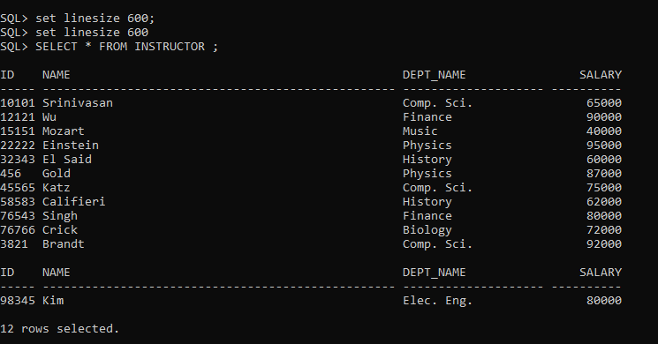

b)
SELECT ID , NAME FROM INSTRUCTOR ;
SQL Command:
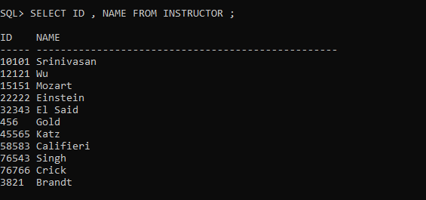
c)
SELECT NAME , DEPT_NAME FROM INSTRUCTOR WHERE SALARY >70000 ;
SQL Command:
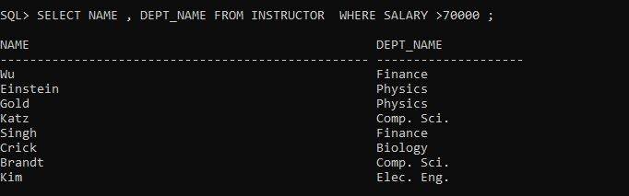

d)

SELECT NAME , DEPT_NAME FROM INSTRUCTOR WHERE 10000< SALARY AND SALARY >80000 ;

SQL Command:
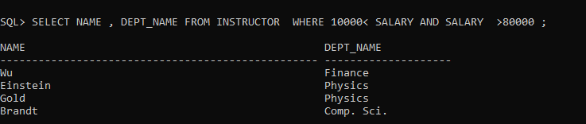
e)

SELECT ID , NAME FROM INSTRUCTOR WHERE DEPT_NAME = ’Comp. Sci. ’;
SQL Command:
f)

SELECT NAME ,SALARY FROM INSTRUCTOR WHERE DEPT_NAME = ’Finance ’ ;

SQL Command:

g)

SELECT ID , NAME FROM INSTRUCTOR WHERE DEPT_NAME = ’Comp. Sci. ’ OR SALARY >75000 ;

SQL Command:
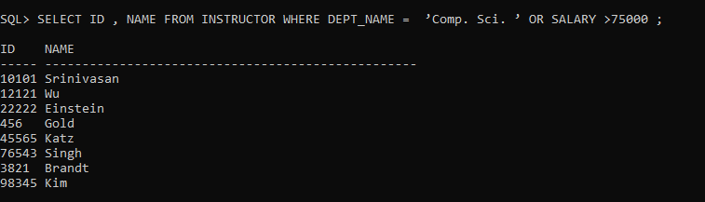
h)

SELECT DEPT_NAME FROM INSTRUCTOR ;

SQL Command:
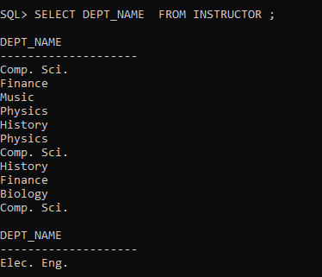
Task 5:
Drop the ’INSTRUCTOR’ table with all its constraints.

Solution Approach:

DROP TABLE INSTRUCTOR CASCADE CONSTRAINTS ;

SQL Command:


Problems Faced:
1. Syntax Errors in CREATE TABLE Statements:
- Incorrect syntax in the CREATE TABLE statement resulted in table creation failures.
- Solution: Double-checking the syntax against SQL documentation or examples to ensure accuracy.
2. Data Integrity Issues in INSERT Statements:
- Providing incorrect values or omitting values in the INSERT statements resulted in data integrity issues.
- Solution: Thorough validation and accuracy checks when inserting data.
3. Handling NULL Values:
- Attributes with NULL values did not behave as expected in comparisons.
- Solution: Properly handling NULL values in queries and data processing.
4. Query Performance Optimization:
- Poorly optimized queries led to slow performance, especially with large datasets.
- Solution: Efficient use of indexes and optimization of complex queries.
5. Permanent Data Deletion:
- Dropping a table permanently removes its data.
- Solution: Exercise caution when performing such operations to prevent data loss.

